A000-Am,S-Colombia-Tairona-Tumnbaga- Cacique seated-1000-1400 CE

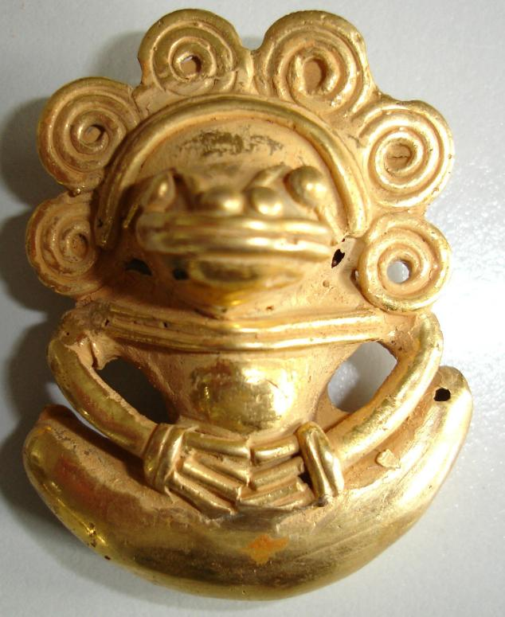

Fig. 1. Colombia-Tairona-Tumnbaga- Cacique seated-1000-1400 CE

Case No.: 7

**Accession No.**

**Formal Label:** Colombia-Tairona-Tumnbaga- Cacique seated-1000-1400 CE

**Display Description:**

This gold worked symbolic image of a cacique or leader of indigenous tribes whose rank was apparently established through democratic means. His importance in the tribe was determined by the size of his tribe rather than his warlord skills. They also enjoyed several privileges for their standing: they lived in a larger rectangular hut in the center of the village and had a special sitting place for the *areytos* (ceremonial dances).

**LC Classification:**

**Date or Time Horizon:**

**Geographical Area:**

**Map:**

**GPS coordinates:**

**Cultural Affiliation:**

**Media:**

**Dimensions:**

**Weight:**

**Condition:**

**Provenance:**

**Discussion:**

**References:**

**Cacique** is a title for the leaders of the other indigenous tribes they encountered in the Western Hemisphere territories they occupied. In the Taíno culture, the cacique rank was apparently established through democratic means. His importance in the tribe was determined by the size of his tribe rather than his warlord skills, since the Taínos were mostly a pacifist culture. They also enjoyed several privileges for their standing: they lived in a larger rectangular hut in the center of the village and had a special sitting place for the *areytos* (ceremonial dances) and the ceremonial ball game.[[2]](http://en.wikipedia.org/wiki/Cacique" \l "cite_note-2)